MOSFET
From Wikipedia, the free encyclopedia
Jump to: navigation, search
 | This article may be too technical for most readers to understand. Please help improve this article to make it understandable to non-experts, without removing the technical details. The talk page may contain suggestions. (October 2013)
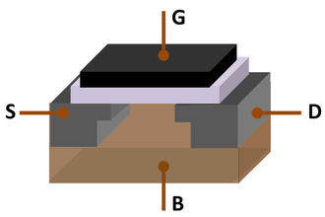
MOSFET showing gate (G), body (B), source (S) and drain (D) terminals. The gate is separated from the body by an insulating layer (white)
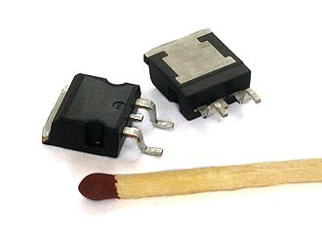
Two power MOSFETs in the surface-mount package D2PAK. Operating as switches, each of these components can sustain a blocking voltage of 120 volts in the OFF state, and can conduct a continuous current of 30 amperes in the ON state, dissipating up to about 100 watts and controlling a load of over 2000 watts. A matchstick is pictured for scale.
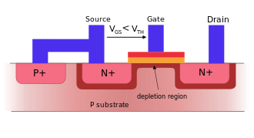
A cross section through an nMOSFET when the gate voltage V_{GS} is below the threshold for making a conductive channel; there is little or no conduction between the terminals drain and source; the switch is off. When the gate is more positive, it attracts electrons, inducing an n-type conductive channel in the substrate below the oxide, which allows electrons to flow between the n-doped terminals; the switch is on.
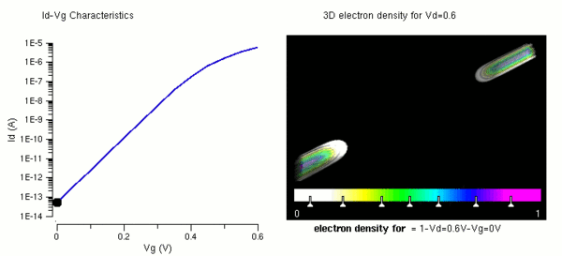
Simulation result for formation of inversion channel (electron density) and attainment of threshold voltage (IV) in a nanowire MOSFET. Note that the threshold voltage for this device lies around 0.45 V.
The metal–oxide–semiconductor field-effect transistor (MOSFET, MOS-FET, or MOS FET) is a transistor used for amplifying or switching electronic signals. Although the MOSFET is a four-terminal device with source (S), gate (G), drain (D), and body (B) terminals,^{[1]} the body (or substrate) of the MOSFET often is connected to the source terminal, making it a three-terminal device like other field-effect transistors. Because these two terminals are normally connected to each other (short-circuited) internally, only three terminals appear in electrical diagrams. The MOSFET is by far the most common transistor in both digital and analog circuits, though the bipolar junction transistor was at one time much more common.
In enhancement mode MOSFETs, a voltage drop across the oxide induces a conducting channel between the source and drain contacts via the field effect. The term "enhancement mode" refers to the increase of conductivity with increase in oxide field that adds carriers to the channel, also referred to as the inversion layer. The channel can contain electrons (called an nMOSFET or nMOS), or holes (called a pMOSFET or pMOS), opposite in type to the substrate, so nMOS is made with a p-type substrate, and pMOS with an n-type substrate (see article on semiconductor devices). In the less common depletion mode MOSFET, detailed later on, the channel consists of carriers in a surface impurity layer of opposite type to the substrate, and conductivity is decreased by application of a field that depletes carriers from this surface layer.^{[2]}
The 'metal' in the name MOSFET is now often a misnomer because the previously metal gate material is now often a layer of polysilicon (polycrystalline silicon). Aluminium had been the gate material until the mid-1970s, when polysilicon became dominant, due to its capability to form self-aligned gates. Metallic gates are regaining popularity, since it is difficult to increase the speed of operation of transistors without metal gates.
Likewise, the 'oxide' in the name can be a misnomer, as different dielectric materials are used with the aim of obtaining strong channels with smaller applied voltages.
An insulated-gate field-effect transistor or IGFET is a related term almost synonymous with MOSFET. The term may be more inclusive, since many "MOSFETs" use a gate that is not metal, and a gate insulator that is not oxide. Another synonym is MISFET for metal–insulator–semiconductor FET.
The basic principle of the field-effect transistor was first patented by Julius Edgar Lilienfeld in 1925.

Contents
- 1 Composition
- 2 Circuit symbols
- 3 MOSFET operation
  - 3.1 Metal–oxide–semiconductor structure
  - 3.2 MOSFET structure and channel formation
  - 3.3 Modes of operation
  - 3.4 Body effect
- 4 History
- 5 CMOS circuits
  - 5.1 Digital
  - 5.2 Analog
- 6 MOSFET scaling
  - 6.1 Reasons for MOSFET scaling
  - 6.2 Difficulties arising due to MOSFET size reduction
    - 6.2.1 Higher subthreshold conduction
    - 6.2.2 Increased gate-oxide leakage
    - 6.2.3 Increased junction leakage
    - 6.2.4 Lower output resistance
    - 6.2.5 Lower transconductance
    - 6.2.6 Interconnect capacitance
    - 6.2.7 Heat production
    - 6.2.8 Process variations
    - 6.2.9 Modeling challenges
- 7 MOSFET construction
  - 7.1 Gate material
  - 7.2 Insulator
  - 7.3 Junction design
- 8 Other MOSFET types
  - 8.1 Dual-gate MOSFET
    - 8.1.1 FinFET
  - 8.2 Depletion-mode MOSFETs
  - 8.3 NMOS logic
  - 8.4 Power MOSFET
  - 8.5 DMOS
  - 8.6 RHBD MOSFETs
- 9 MOSFET analog switch
  - 9.1 Single-type MOSFET switch
  - 9.2 Dual-type (CMOS) MOSFET switch
- 10 See also
- 11 References
- 12 External links

Composition
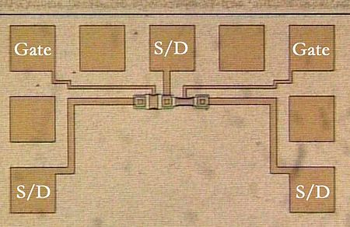
Photomicrograph of two metal-gate MOSFETs in a test pattern. Probe pads for two gates and three source/drain nodes are labeled.
Usually the semiconductor of choice is silicon, but some chip manufacturers, most notably IBM and Intel, recently started using a chemical compound of silicon and germanium (SiGe) in MOSFET channels. Unfortunately, many semiconductors with better electrical properties than silicon, such as gallium arsenide, do not form good semiconductor-to-insulator interfaces, thus are not suitable for MOSFETs. Research continues on creating insulators with acceptable electrical characteristics on other semiconductor material.
In order to overcome the increase in power consumption due to gate current leakage, a high-κ dielectric is used instead of silicon dioxide for the gate insulator, while polysilicon is replaced by metal gates (see Intel announcement^{[3]}).
The gate is separated from the channel by a thin insulating layer, traditionally of silicon dioxide and later of silicon oxynitride. Some companies have started to introduce a high-κ dielectric + metal gate combination in the 45 nanometer node.
When a voltage is applied between the gate and body terminals, the electric field generated penetrates through the oxide and creates an "inversion layer" or "channel" at the semiconductor-insulator interface. The inversion channel is of the same type, p-type or n-type, as the source and drain, thus it provides a channel through which current can pass. Varying the voltage between the gate and body modulates the conductivity of this layer and thereby controls the current flow between drain and source.

Circuit symbols
A variety of symbols are used for the MOSFET. The basic design is generally a line for the channel with the source and drain leaving it at right angles and then bending back at right angles into the same direction as the channel. Sometimes three line segments are used for enhancement mode and a solid line for depletion mode. (see Depletion and enhancement modes) Another line is drawn parallel to the channel for the gate.
The bulk connection, if shown, is shown connected to the back of the channel with an arrow indicating PMOS or NMOS. Arrows always point from P to N, so an NMOS (N-channel in P-well or P-substrate) has the arrow pointing in (from the bulk to the channel). If the bulk is connected to the source (as is generally the case with discrete devices) it is sometimes angled to meet up with the source leaving the transistor. If the bulk is not shown (as is often the case in IC design as they are generally common bulk) an inversion symbol is sometimes used to indicate PMOS, alternatively an arrow on the source may be used in the same way as for bipolar transistors (out for nMOS, in for pMOS).
Comparison of enhancement-mode and depletion-mode MOSFET symbols, along with JFET symbols (drawn with source and drain ordered such that higher voltages appear higher on the page than lower voltages):^{[4][5][6]}
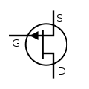 | 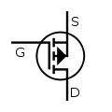 | 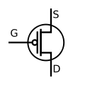 | 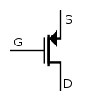 | 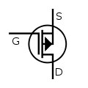 | P-channel
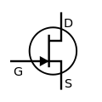 | 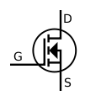 | 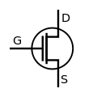 | 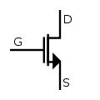 | 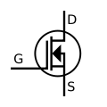 | N-channel
JFET | MOSFET enh | MOSFET enh (no bulk) |  | MOSFET dep
For the symbols in which the bulk, or body, terminal is shown, it is here shown internally connected to the source. This is a typical configuration, but by no means the only important configuration. In general, the MOSFET is a four-terminal device, and in integrated circuits many of the MOSFETs share a body connection, not necessarily connected to the source terminals of all the transistors.

MOSFET operation
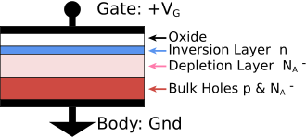
Metal–oxide–semiconductor structure on p-type silicon

Metal–oxide–semiconductor structure
The traditional metal–oxide–semiconductor (MOS) structure is obtained by growing a layer of silicon dioxide (SiO₂) on top of a silicon substrate and depositing a layer of metal or polycrystalline silicon (the latter is commonly used). As the silicon dioxide is a dielectric material, its structure is equivalent to a planar capacitor, with one of the electrodes replaced by a semiconductor. When a voltage is applied across a MOS structure, it modifies the distribution of charges in the semiconductor. If we consider a p-type semiconductor (with the density of acceptors, p the density of holes; p = N_{A} in neutral bulk), a positive voltage, , from gate to body (see figure) creates a depletion layer by forcing the positively charged holes away from the gate-insulator/semiconductor interface, leaving exposed a carrier-free region of immobile, negatively charged acceptor ions (see doping (semiconductor)). If is high enough, a high concentration of negative charge carriers forms in an inversion layer located in a thin layer next to the interface between the semiconductor and the insulator. Unlike the MOSFET, where the inversion layer electrons are supplied rapidly from the source/drain electrodes, in the MOS capacitor they are produced much more slowly by thermal generation through carrier generation and recombination centers in the depletion region. Conventionally, the gate voltage at which the volume density of electrons in the inversion layer is the same as the volume density of holes in the body is called the threshold voltage. When the voltage between transistor gate and source (V_{GS}) exceeds the threshold voltage (V_{th}), it is known as overdrive voltage.
This structure with p-type body is the basis of the n-type MOSFET, which requires the addition of an n-type source and drain regions.

MOSFET structure and channel formation
See also: Field effect (semiconductor)
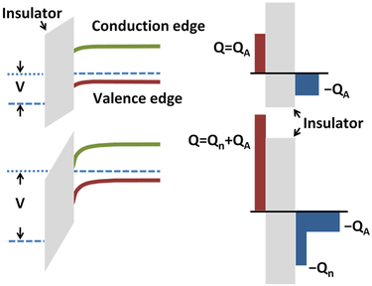
Channel formation in nMOS MOSFET shown as band diagram: Top panels: An applied gate voltage bends bands, depleting holes from surface (left). The charge inducing the bending is balanced by a layer of negative acceptor-ion charge (right). Bottom panel: A larger applied voltage further depletes holes but conduction band lowers enough in energy to populate a conducting channel.
A metal–oxide–semiconductor field-effect transistor (MOSFET) is based on the modulation of charge concentration by a MOS capacitance between a body electrode and a gate electrode located above the body and insulated from all other device regions by a gate dielectric layer which in the case of a MOSFET is an oxide, such as silicon dioxide. If dielectrics other than an oxide such as silicon dioxide (often referred to as oxide) are employed the device may be referred to as a metal–insulator–semiconductor FET (MISFET). Compared to the MOS capacitor, the MOSFET includes two additional terminals (source and drain), each connected to individual highly doped regions that are separated by the body region. These regions can be either p or n type, but they must both be of the same type, and of opposite type to the body region. The source and drain (unlike the body) are highly doped as signified by a '+' sign after the type of doping.
If the MOSFET is an n-channel or nMOS FET, then the source and drain are 'n+' regions and the body is a 'p' region. If the MOSFET is a p-channel or pMOS FET, then the source and drain are 'p+' regions and the body is a 'n' region. The source is so named because it is the source of the charge carriers (electrons for n-channel, holes for p-channel) that flow through the channel; similarly, the drain is where the charge carriers leave the channel.
The occupancy of the energy bands in a semiconductor is set by the position of the Fermi level relative to the semiconductor energy-band edges. As described above, and shown in the figure, with sufficient gate voltage, the valence band edge is driven far from the Fermi level, and holes from the body are driven away from the gate. At larger gate bias still, near the semiconductor surface the conduction band edge is brought close to the Fermi level, populating the surface with electrons in an inversion layer or n-channel at the interface between the p region and the oxide. This conducting channel extends between the source and the drain, and current is conducted through it when a voltage is applied between the two electrodes. Increasing the voltage on the gate leads to a higher electron density in the inversion layer and therefore increases the current flow between the source and drain.
For gate voltages below the threshold value, the channel is lightly populated, and only a very small subthreshold leakage current can flow between the source and the drain.
When a negative gate-source voltage (positive source-gate) is applied, it creates a p-channel at the surface of the n region, analogous to the n-channel case, but with opposite polarities of charges and voltages. When a voltage less negative than the threshold value (a negative voltage for p-channel) is applied between gate and source, the channel disappears and only a very small subthreshold current can flow between the source and the drain.
The device may comprise a Silicon On Insulator (SOI) device in which a buried oxide (BOX) is formed below a thin semiconductor layer. If the channel region between the gate dielectric and a BOX region is very thin, the very thin channel region is referred to as an ultrathin channel (UTC) region with the source and drain regions formed on either side thereof in and/or above the thin semiconductor layer. Alternatively, the device may comprise a semiconductor on insulator (SEMOI) device in which semiconductors other than silicon are employed. Many alternative semiconductor materials may be employed.
When the source and drain regions are formed above the channel in whole or in part, they are referred to as raised source/drain (RSD) regions.

Modes of operation
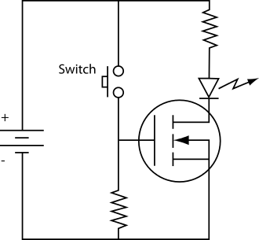
Example application of an N-Channel MOSFET. When the switch is pushed the LED lights up.^{[7]}
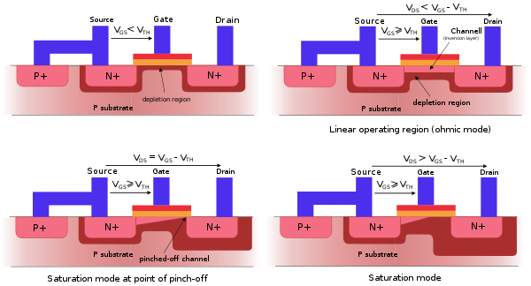
Ohmic contact to body to ensure no body bias; top left:subthreshold, top right:Ohmic mode, bottom left:Active mode at onset of pinch-off, bottom right: Active mode well into pinch-off – channel length modulation evident
The operation of a MOSFET can be separated into three different modes, depending on the voltages at the terminals. In the following discussion, a simplified algebraic model is used.^{[8]} Modern MOSFET characteristics are more complex than the algebraic model presented here.^{[9]}
For an enhancement-mode, n-channel MOSFET, the three operational modes are:
Cutoff, subthreshold, or weak-inversion mode
When V_{GS} < V_{th}:
where is gate-to-source bias and is the threshold voltage of the device.
According to the basic threshold model, the transistor is turned off, and there is no conduction between drain and source. A more accurate model considers the effect of thermal energy on the Boltzmann distribution of electron energies which allow some of the more energetic electrons at the source to enter the channel and flow to the drain. This results in a subthreshold current that is an exponential function of gate–source voltage. While the current between drain and source should ideally be zero when the transistor is being used as a turned-off switch, there is a weak-inversion current, sometimes called subthreshold leakage.
In weak inversion where the source is tied to bulk, the current varies exponentially with as given approximately by:^{[10][11]}
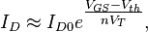
where = current at , the thermal voltage and the slope factor n is given by
with = capacitance of the depletion layer and = capacitance of the oxide layer. This equation is generally used, but is only an adequate approximation for the source tied to the bulk. For the source not tied to the bulk, the subthreshold equation for drain current in saturation is ^{[12][13]}
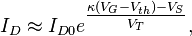
where the is the channel divider that is given by
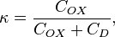
with = capacitance of the depletion layer and = capacitance of the oxide layer. In a long-channel device, there is no drain voltage dependence of the current once , but as channel length is reduced drain-induced barrier lowering introduces drain voltage dependence that depends in a complex way upon the device geometry (for example, the channel doping, the junction doping and so on). Frequently, threshold voltage V_{th} for this mode is defined as the gate voltage at which a selected value of current I_{D0} occurs, for example, I_{D0} = 1 μA, which may not be the same V_{th}-value used in the equations for the following modes.
Some micropower analog circuits are designed to take advantage of subthreshold conduction.^{[14][15][16]} By working in the weak-inversion region, the MOSFETs in these circuits deliver the highest possible transconductance-to-current ratio, namely: , almost that of a bipolar transistor.^{[17]}
The subthreshold I–V curve depends exponentially upon threshold voltage, introducing a strong dependence on any manufacturing variation that affects threshold voltage; for example: variations in oxide thickness, junction depth, or body doping that change the degree of drain-induced barrier lowering. The resulting sensitivity to fabricational variations complicates optimization for leakage and performance.^{[18][19]}
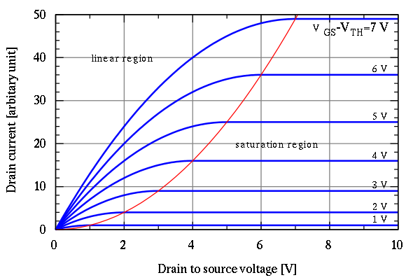
MOSFET drain current vs. drain-to-source voltage for several values of ; the boundary between linear (Ohmic) and saturation (active) modes is indicated by the upward curving parabola.
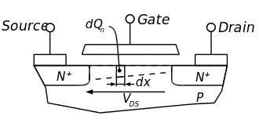
Cross section of a MOSFET operating in the linear (Ohmic) region; strong inversion region present even near drain
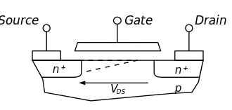
Cross section of a MOSFET operating in the saturation (active) region; channel exhibits pinch-off near drain
Triode mode or linear region (also known as the ohmic mode^{[20][21]})
When V_{GS} > V_{th} and V_{DS} < ( V_{GS} – V_{th} )
The transistor is turned on, and a channel has been created which allows current to flow between the drain and the source. The MOSFET operates like a resistor, controlled by the gate voltage relative to both the source and drain voltages. The current from drain to source is modeled as:
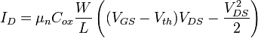
where is the charge-carrier effective mobility, is the gate width, is the gate length and is the gate oxide capacitance per unit area. The transition from the exponential subthreshold region to the triode region is not as sharp as the equations suggest.
Saturation or active mode^{[22][23]}
When V_{GS} > V_{th} and V_{DS} ≥ ( V_{GS} – V_{th} )
The switch is turned on, and a channel has been created, which allows current to flow between the drain and source. Since the drain voltage is higher than the source voltage, the electrons spread out, and conduction is not through a narrow channel but through a broader, two- or three-dimensional current distribution extending away from the interface and deeper in the substrate. The onset of this region is also known as pinch-off to indicate the lack of channel region near the drain. The drain current is now weakly dependent upon drain voltage and controlled primarily by the gate–source voltage, and modeled approximately as:
The additional factor involving λ, the channel-length modulation parameter, models current dependence on drain voltage due to the Early effect, or channel length modulation. According to this equation, a key design parameter, the MOSFET transconductance is:
where the combination V_{ov} = V_{GS} – V_{th} is called the overdrive voltage,^{[24]} and where V_{DSsat} = V_{GS} – V_{th} (which Sedra neglects) accounts for a small discontinuity in which would otherwise appear at the transition between the triode and saturation regions.
Another key design parameter is the MOSFET output resistance r_{out} given by:
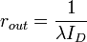.
r_{out} is the inverse of g_{DS} where 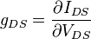. I_{D} is the expression in saturation region.
If λ is taken as zero, an infinite output resistance of the device results that leads to unrealistic circuit predictions, particularly in analog circuits.
As the channel length becomes very short, these equations become quite inaccurate. New physical effects arise. For example, carrier transport in the active mode may become limited by velocity saturation. When velocity saturation dominates, the saturation drain current is more nearly linear than quadratic in V_{GS}. At even shorter lengths, carriers transport with near zero scattering, known as quasi-ballistic transport. In the ballistic regime, the carriers travel at an injection velocity that may exceed the saturation velocity and approaches the Fermi velocity at high inversion charge density. In addition, drain-induced barrier lowering increases off-state (cutoff) current and requires an increase in threshold voltage to compensate, which in turn reduces the saturation current.

Body effect
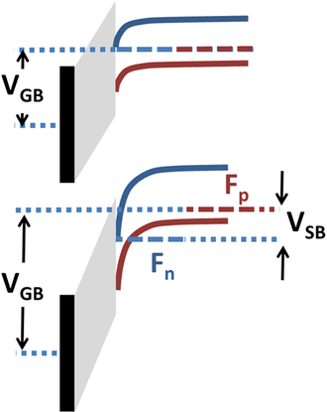
Band diagram showing body effect. V_{SB} splits Fermi levels F_{n} for electrons and F_{p} for holes, requiring larger V_{GB} to populate the conduction band in an nMOS MOSFET
The occupancy of the energy bands in a semiconductor is set by the position of the Fermi level relative to the semiconductor energy-band edges. Application of a source-to-substrate reverse bias of the source-body pn-junction introduces a split between the Fermi levels for electrons and holes, moving the Fermi level for the channel further from the band edge, lowering the occupancy of the channel. The effect is to increase the gate voltage necessary to establish the channel, as seen in the figure. This change in channel strength by application of reverse bias is called the body effect.
Simply put, using an nMOS example, the gate-to-body bias V_{GB} positions the conduction-band energy levels, while the source-to-body bias V_{SB} positions the electron Fermi level near the interface, deciding occupancy of these levels near the interface, and hence the strength of the inversion layer or channel.
The body effect upon the channel can be described using a modification of the threshold voltage, approximated by the following equation:
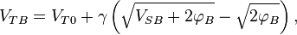
where V_{TB} is the threshold voltage with substrate bias present, and V_{T0} is the zero-V_{SB} value of threshold voltage, is the body effect parameter, and 2φ_{B} is the approximate potential drop between surface and bulk across the depletion layer when V_{SB} = 0 and gate bias is sufficient to insure that a channel is present.^{[25]} As this equation shows, a reverse bias V_{SB} > 0 causes an increase in threshold voltage V_{TB} and therefore demands a larger gate voltage before the channel populates.
The body can be operated as a second gate, and is sometimes referred to as the "back gate"; the body effect is sometimes called the "back-gate effect".^{[26]}

History
The basic principle of this kind of transistor was first patented by Julius Edgar Lilienfeld in 1925. Twenty five years later, when Bell Telephone attempted to patent the junction transistor, they found Lilienfeld already holding a patent which was worded in a way that would include all types of transistors. Bell Labs was able to work out an agreement with Lilienfeld, who was still alive at that time (it is not known if they paid him money or not).^{[citation needed]} It was at that time the Bell Labs version was given the name bipolar junction transistor, or simply junction transistor, and Lilienfeld's design took the name field effect transistor.^{[citation needed]}
In 1959, Dawon Kahng and Martin M. (John) Atalla at Bell Labs invented the metal–oxide–semiconductor field-effect transistor (MOSFET) as an offshoot to the patented FET design.^{[27]} Operationally and structurally different from the bipolar junction transistor,^{[28]} the MOSFET was made by putting an insulating layer on the surface of the semiconductor and then placing a metallic gate electrode on that. It used crystalline silicon for the semiconductor and a thermally oxidized layer of silicon dioxide for the insulator. The silicon MOSFET did not generate localized electron traps at the interface between the silicon and its native oxide layer, and thus was inherently free from the trapping and scattering of carriers that had impeded the performance of earlier field-effect transistors. Following the development of clean rooms to reduce contamination to levels never before thought necessary, and of photolithography^{[29]} and the planar process to allow circuits to be made in very few steps, the Si–SiO₂ system possessed such technical attractions as low cost of production (on a per circuit basis) and ease of integration. Largely because of these two factors, the MOSFET has become the most widely used type of transistor in integrated circuits.
Additionally, the method of coupling two complementary MOSFETS (P-channel and N-channel) into one high/low switch, known as CMOS, means that digital circuits dissipate very little power except when actually switched.
The earliest microprocessors starting in 1970 were all "MOS microprocessors" -- i.e., fabricated entirely from PMOS logic or fabricated entirely from NMOS logic. In the 1970s, "MOS microprocessors" were often contrasted with "CMOS microprocessors" and "bipolar bit-slice processors".^{[30]}

CMOS circuits
The MOSFET is used in digital complementary metal–oxide–semiconductor (CMOS) logic,^{[31]} which uses p- and n-channel MOSFETs as building blocks. Overheating is a major concern in integrated circuits since ever more transistors are packed into ever smaller chips. CMOS logic reduces power consumption because no current flows (ideally), and thus no power is consumed, except when the inputs to logic gates are being switched. CMOS accomplishes this current reduction by complementing every nMOSFET with a pMOSFET and connecting both gates and both drains together. A high voltage on the gates will cause the nMOSFET to conduct and the pMOSFET not to conduct and a low voltage on the gates causes the reverse. During the switching time as the voltage goes from one state to another, both MOSFETs will conduct briefly. This arrangement greatly reduces power consumption and heat generation. Digital and analog CMOS applications are described below.

Digital
The growth of digital technologies like the microprocessor has provided the motivation to advance MOSFET technology faster than any other type of silicon-based transistor.^{[32]} A big advantage of MOSFETs for digital switching is that the oxide layer between the gate and the channel prevents DC current from flowing through the gate, further reducing power consumption and giving a very large input impedance. The insulating oxide between the gate and channel effectively isolates a MOSFET in one logic stage from earlier and later stages, which allows a single MOSFET output to drive a considerable number of MOSFET inputs. Bipolar transistor-based logic (such as TTL) does not have such a high fanout capacity. This isolation also makes it easier for the designers to ignore to some extent loading effects between logic stages independently. That extent is defined by the operating frequency: as frequencies increase, the input impedance of the MOSFETs decreases.

Analog
The MOSFET's advantages in digital circuits do not translate into supremacy in all analog circuits. The two types of circuit draw upon different features of transistor behavior. Digital circuits switch, spending most of their time outside the switching region, while analog circuits depend on MOSFET behavior held precisely in the switching region of operation. The bipolar junction transistor (BJT) has traditionally been the analog designer's transistor of choice, due largely to its higher transconductance and its lower output impedance (drain-voltage independence) in the switching region.
Nevertheless, MOSFETs are widely used in many types of analog circuits because of certain advantages. The characteristics and performance of many analog circuits can be designed by changing the sizes (length and width) of the MOSFETs used. By comparison, in most bipolar transistors the size of the device does not significantly affect the performance. MOSFETs' ideal characteristics regarding gate current (zero) and drain-source offset voltage (zero) also make them nearly ideal switch elements, and also make switched capacitor analog circuits practical. In their linear region, MOSFETs can be used as precision resistors, which can have a much higher controlled resistance than BJTs. In high power circuits, MOSFETs sometimes have the advantage of not suffering from thermal runaway as BJTs do. Also, they can be formed into capacitors and gyrator circuits which allow op-amps made from them to appear as inductors, thereby allowing all of the normal analog devices, except for diodes (which can be made smaller than a MOSFET anyway), to be built entirely out of MOSFETs. This allows for complete analog circuits to be made on a silicon chip in a much smaller space.
Some ICs combine analog and digital MOSFET circuitry on a single mixed-signal integrated circuit, making the needed board space even smaller. This creates a need to isolate the analog circuits from the digital circuits on a chip level, leading to the use of isolation rings and Silicon-On-Insulator (SOI). The main advantage of BJTs versus MOSFETs in the analog design process is the ability of BJTs to handle a larger current in a smaller space. Fabrication processes exist that incorporate BJTs and MOSFETs into a single device. Mixed-transistor devices are called Bi-FETs (bipolar FETs) if they contain just one BJT-FET and BiCMOS (bipolar-CMOS) if they contain complementary BJT-FETs. Such devices have the advantages of both insulated gates and higher current density.

MOSFET scaling
Over the past decades, the MOSFET has continually been scaled down in size; typical MOSFET channel lengths were once several micrometres, but modern integrated circuits are incorporating MOSFETs with channel lengths of tens of nanometers. Robert Dennard's work on scaling theory was pivotal in recognising that this ongoing reduction was possible. Intel began production of a process featuring a 32 nm feature size (with the channel being even shorter) in late 2009. The semiconductor industry maintains a "roadmap", the ITRS,^{[33]} which sets the pace for MOSFET development. Historically, the difficulties with decreasing the size of the MOSFET have been associated with the semiconductor device fabrication process, the need to use very low voltages, and with poorer electrical performance necessitating circuit redesign and innovation (small MOSFETs exhibit higher leakage currents, and lower output resistance, discussed below).

Reasons for MOSFET scaling
Smaller MOSFETs are desirable for several reasons. The main reason to make transistors smaller is to pack more and more devices in a given chip area. This results in a chip with the same functionality in a smaller area, or chips with more functionality in the same area. Since fabrication costs for a semiconductor wafer are relatively fixed, the cost per integrated circuits is mainly related to the number of chips that can be produced per wafer. Hence, smaller ICs allow more chips per wafer, reducing the price per chip. In fact, over the past 30 years the number of transistors per chip has been doubled every 2–3 years once a new technology node is introduced. For example the number of MOSFETs in a microprocessor fabricated in a 45 nm technology can well be twice as many as in a 65 nm chip. This doubling of transistor density was first observed by Gordon Moore in 1965 and is commonly referred to as Moore's law.^{[34]}
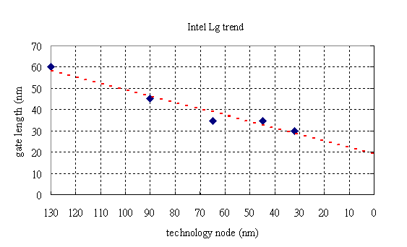
Trend of Intel CPU transistor gate length
It is also expected that smaller transistors switch faster. For example, one approach to size reduction is a scaling of the MOSFET that requires all device dimensions to reduce proportionally. The main device dimensions are the channel length, channel width, and oxide thickness. When they are scaled down by equal factors, the transistor channel resistance does not change, while gate capacitance is cut by that factor. Hence, the RC delay of the transistor scales with a similar factor.
While this has been traditionally the case for the older technologies, for the state-of-the-art MOSFETs reduction of the transistor dimensions does not necessarily translate to higher chip speed because the delay due to interconnections is more significant.

Difficulties arising due to MOSFET size reduction
Producing MOSFETs with channel lengths much smaller than a micrometre is a challenge, and the difficulties of semiconductor device fabrication are always a limiting factor in advancing integrated circuit technology. In recent years, the small size of the MOSFET, below a few tens of nanometers, has created operational problems.

Higher subthreshold conduction
As MOSFET geometries shrink, the voltage that can be applied to the gate must be reduced to maintain reliability. To maintain performance, the threshold voltage of the MOSFET has to be reduced as well. As threshold voltage is reduced, the transistor cannot be switched from complete turn-off to complete turn-on with the limited voltage swing available; the circuit design is a compromise between strong current in the "on" case and low current in the "off" case, and the application determines whether to favor one over the other. Subthreshold leakage (including subthreshold conduction, gate-oxide leakage and reverse-biased junction leakage), which was ignored in the past, now can consume upwards of half of the total power consumption of modern high-performance VLSI chips.^{[35][36][37]}

Increased gate-oxide leakage
The gate oxide, which serves as insulator between the gate and channel, should be made as thin as possible to increase the channel conductivity and performance when the transistor is on and to reduce subthreshold leakage when the transistor is off. However, with current gate oxides with a thickness of around 1.2 nm (which in silicon is ~5 atoms thick) the quantum mechanical phenomenon of electron tunneling occurs between the gate and channel, leading to increased power consumption.
Silicon dioxide has traditionally been used as the gate insulator. Silicon dioxide however has a modest dielectric constant. Increasing the dielectric constant of the gate dielectric allows a thicker layer while maintaining a high capacitance (capacitance is proportional to dielectric constant and inversely proportional to dielectric thickness). All else equal, a higher dielectric thickness reduces the quantum tunneling current through the dielectric between the gate and the channel.
Insulators that have a larger dielectric constant than silicon dioxide (referred to as high-k dielectrics), such as group IVb metal silicates e.g. hafnium and zirconium silicates and oxides are being used to reduce the gate leakage from the 45 nanometer technology node onwards.
On the other hand, the barrier height of the new gate insulator is an important consideration; the difference in conduction band energy between the semiconductor and the dielectric (and the corresponding difference in valence band energy) also affects leakage current level. For the traditional gate oxide, silicon dioxide, the former barrier is approximately 8 eV. For many alternative dielectrics the value is significantly lower, tending to increase the tunneling current, somewhat negating the advantage of higher dielectric constant.
The maximum gate-source voltage is determined by the strength of the electric field able to be sustained by the gate dielectric before significant leakage occurs. As the insulating dielectric is made thinner, the electric field strength within it goes up for a fixed voltage. This necessitates using lower voltages with the thinner dielectric.

Increased junction leakage
To make devices smaller, junction design has become more complex, leading to higher doping levels, shallower junctions, "halo" doping and so forth,^{[38][39]} all to decrease drain-induced barrier lowering (see the section on junction design). To keep these complex junctions in place, the annealing steps formerly used to remove damage and electrically active defects must be curtailed^{[40]} increasing junction leakage. Heavier doping is also associated with thinner depletion layers and more recombination centers that result in increased leakage current, even without lattice damage.
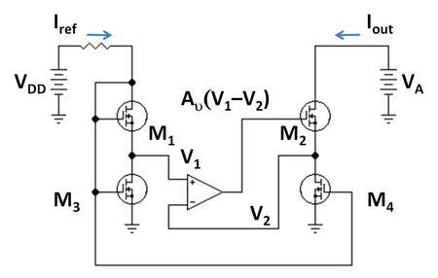
MOSFET version of gain-boosted current mirror; M₁ and M₂ are in active mode, while M₃ and M₄ are in Ohmic mode, and act like resistors. The operational amplifier provides feedback that maintains a high output resistance.

Lower output resistance
For analog operation, good gain requires a high MOSFET output impedance, which is to say, the MOSFET current should vary only slightly with the applied drain-to-source voltage. As devices are made smaller, the influence of the drain competes more successfully with that of the gate due to the growing proximity of these two electrodes, increasing the sensitivity of the MOSFET current to the drain voltage. To counteract the resulting decrease in output resistance, circuits are made more complex, either by requiring more devices, for example the cascode and cascade amplifiers, or by feedback circuitry using operational amplifiers, for example a circuit like that in the adjacent figure.

Lower transconductance
The transconductance of the MOSFET decides its gain and is proportional to hole or electron mobility (depending on device type), at least for low drain voltages. As MOSFET size is reduced, the fields in the channel increase and the dopant impurity levels increase. Both changes reduce the carrier mobility, and hence the transconductance. As channel lengths are reduced without proportional reduction in drain voltage, raising the electric field in the channel, the result is velocity saturation of the carriers, limiting the current and the transconductance.

Interconnect capacitance
Traditionally, switching time was roughly proportional to the gate capacitance of gates. However, with transistors becoming smaller and more transistors being placed on the chip, interconnect capacitance (the capacitance of the metal-layer connections between different parts of the chip) is becoming a large percentage of capacitance.^{[41]} ^{[42]} Signals have to travel through the interconnect, which leads to increased delay and lower performance.

Heat production
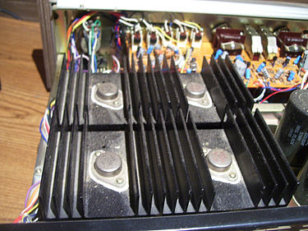
Large heatsinks to cool power transistors in a TRM-800 audio amplifier
The ever-increasing density of MOSFETs on an integrated circuit creates problems of substantial localized heat generation that can impair circuit operation. Circuits operate more slowly at high temperatures, and have reduced reliability and shorter lifetimes. Heat sinks and other cooling devices and methods are now required for many integrated circuits including microprocessors.
Power MOSFETs are at risk of thermal runaway. As their on-state resistance rises with temperature, if the load is approximately a constant-current load then the power loss rises correspondingly, generating further heat. When the heatsink is not able to keep the temperature low enough, the junction temperature may rise quickly and uncontrollably, resulting in destruction of the device.

Process variations
With MOSFETS becoming smaller, the number of atoms in the silicon that produce many of the transistor's properties is becoming fewer, with the result that control of dopant numbers and placement is more erratic. During chip manufacturing, random process variations affect all transistor dimensions: length, width, junction depths, oxide thickness etc., and become a greater percentage of overall transistor size as the transistor shrinks. The transistor characteristics become less certain, more statistical. The random nature of manufacture means we do not know which particular example MOSFETs actually will end up in a particular instance of the circuit. This uncertainty forces a less optimal design because the design must work for a great variety of possible component MOSFETs. See process variation, design for manufacturability, reliability engineering, and statistical process control.^{[43]}

Modeling challenges
Modern ICs are computer-simulated with the goal of obtaining working circuits from the very first manufactured lot. As devices are miniaturized, the complexity of the processing makes it difficult to predict exactly what the final devices look like, and modeling of physical processes becomes more challenging as well. In addition, microscopic variations in structure due simply to the probabilistic nature of atomic processes require statistical (not just deterministic) predictions. These factors combine to make adequate simulation and "right the first time" manufacture difficult.

MOSFET construction

Gate material
The primary criterion for the gate material is that it is a good conductor. Highly doped polycrystalline silicon is an acceptable but certainly not ideal conductor, and also suffers from some more technical deficiencies in its role as the standard gate material. Nevertheless, there are several reasons favoring use of polysilicon:
- The threshold voltage (and consequently the drain to source on-current) is modified by the work function difference between the gate material and channel material. Because polysilicon is a semiconductor, its work function can be modulated by adjusting the type and level of doping. Furthermore, because polysilicon has the same bandgap as the underlying silicon channel, it is quite straightforward to tune the work function to achieve low threshold voltages for both NMOS and PMOS devices. By contrast, the work functions of metals are not easily modulated, so tuning the work function to obtain low threshold voltages becomes a significant challenge. Additionally, obtaining low-threshold devices on both PMOS and NMOS devices would likely require the use of different metals for each device type, introducing additional complexity to the fabrication process.
- The silicon-SiO₂ interface has been well studied and is known to have relatively few defects. By contrast many metal–insulator interfaces contain significant levels of defects which can lead to Fermi level pinning, charging, or other phenomena that ultimately degrade device performance.
- In the MOSFET IC fabrication process, it is preferable to deposit the gate material prior to certain high-temperature steps in order to make better-performing transistors. Such high temperature steps would melt some metals, limiting the types of metal that can be used in a metal-gate-based process.
While polysilicon gates have been the de facto standard for the last twenty years, they do have some disadvantages which have led to their likely future replacement by metal gates. These disadvantages include:
- Polysilicon is not a great conductor (approximately 1000 times more resistive than metals) which reduces the signal propagation speed through the material. The resistivity can be lowered by increasing the level of doping, but even highly doped polysilicon is not as conductive as most metals. To improve conductivity further, sometimes a high-temperature metal such as tungsten, titanium, cobalt, and more recently nickel is alloyed with the top layers of the polysilicon. Such a blended material is called silicide. The silicide-polysilicon combination has better electrical properties than polysilicon alone and still does not melt in subsequent processing. Also the threshold voltage is not significantly higher than with polysilicon alone, because the silicide material is not near the channel. The process in which silicide is formed on both the gate electrode and the source and drain regions is sometimes called salicide, self-aligned silicide.
- When the transistors are extremely scaled down, it is necessary to make the gate dielectric layer very thin, around 1 nm in state-of-the-art technologies. A phenomenon observed here is the so-called poly depletion, where a depletion layer is formed in the gate polysilicon layer next to the gate dielectric when the transistor is in the inversion. To avoid this problem, a metal gate is desired. A variety of metal gates such as tantalum, tungsten, tantalum nitride, and titanium nitride are used, usually in conjunction with high-k dielectrics. An alternative is to use fully silicided polysilicon gates, a process known as FUSI.
Present high performance CPUs use metal gate technology, together with high-k dielectrics, a combination known as HKMG (High-K, Metal Gate). The disadvantages of metal gates are overcome by a few techniques:^{[44]}
- The threshold voltage is tuned by including a thin "work function metal" layer between the high-K dielectric and the main metal. This layer is thin enough that the total work function of the gate is influenced by both the main metal and thin metal work functions (either due to alloying during annealing, or simply due to the incomplete screening by the thin metal). The threshold voltage thus can be tuned by the thickness of the thin metal layer.
- High-K dielectrics are now well studied, and their defects are understood.
- HKMG processes exist that do not require the metals to experience high temperature anneals; other processes select metals that can survive the annealing step.

Insulator
As devices are made smaller, insulating layers are made thinner, and at some point tunneling of carriers through the insulator from the channel to the gate electrode takes place. To reduce the resulting leakage current, the insulator can be made thicker by choosing a material with a higher dielectric constant. To see how thickness and dielectric constant are related, note that Gauss' law connects field to charge as:
with Q = charge density, κ = dielectric constant, ε₀ = permittivity of empty space and E = electric field. From this law it appears the same charge can be maintained in the channel at a lower field provided κ is increased. The voltage on the gate is given by:
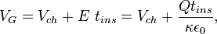
with V_{G} = gate voltage, V_{ch} = voltage at channel side of insulator, and t_{ins} = insulator thickness. This equation shows the gate voltage will not increase when the insulator thickness increases, provided κ increases to keep t_{ins} /κ = constant (see the article on high-κ dielectrics for more detail, and the section in this article on gate-oxide leakage).
The insulator in a MOSFET is a dielectric which can in any event be silicon oxide, but many other dielectric materials are employed. The generic term for the dielectric is gate dielectric since the dielectric lies directly below the gate electrode and above the channel of the MOSFET.

Junction design
The source-to-body and drain-to-body junctions are the object of much attention because of three major factors: their design affects the current-voltage (I-V) characteristics of the device, lowering output resistance, and also the speed of the device through the loading effect of the junction capacitances, and finally, the component of stand-by power dissipation due to junction leakage.
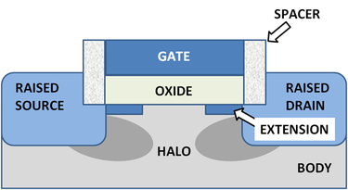
MOSFET showing shallow junction extensions, raised source and drain and halo implant. Raised source and drain separated from gate by oxide spacers.
The drain induced barrier lowering of the threshold voltage and channel length modulation effects upon I-V curves are reduced by using shallow junction extensions. In addition, halo doping can be used, that is, the addition of very thin heavily doped regions of the same doping type as the body tight against the junction walls to limit the extent of depletion regions.^{[45]}
The capacitive effects are limited by using raised source and drain geometries that make most of the contact area border thick dielectric instead of silicon. ^{[46]}
These various features of junction design are shown (with artistic license) in the figure.
Junction leakage is discussed further in the section increased junction leakage.

Other MOSFET types

Dual-gate MOSFET
Main article: Multigate device
The dual-gate MOSFET has a tetrode configuration, where both gates control the current in the device. It is commonly used for small-signal devices in radio frequency applications where biasing the drain-side gate at constant potential reduces the gain loss caused by Miller effect, replacing two separate transistors in cascode configuration. Other common uses in RF crcuits include gain control and mixing (frequency conversion). The "tetrode" description, though accurate, does not replicate the vacuum-tube tetrode. Vacuum-tube tetrodes, using a screen grid, exhibit much lower grid-plate capacitance and much higher output impedance and voltage gains than triode vacuum tubes. These improvements are commonly an order of magnitude (10 times) or considerably more. Tetrode transistors (whether bipolar junction or field-effect) do not exhibit improvements of such a great degree.

FinFET
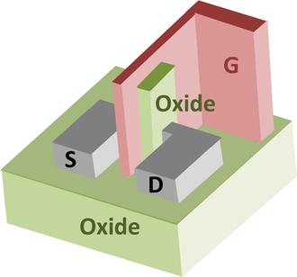
A FinFET MOSFET
The FinFET, see figure to right, is a double-gate silicon-on-insulator device, one of a number of geometries being introduced to mitigate the effects of short channels and reduce drain-induced barrier lowering. The "fin" refers to the narrow channel between source and drain. A thin insulating oxide layer on either side of the fin separates it from the gate. SOI FinFETs with a thick oxide on top of the fin are called double-gate and those with a thin oxide on top as well as on the sides are called triple-gate FinFETs.^{[47]}

Depletion-mode MOSFETs
There are depletion-mode MOSFET devices, which are less commonly used than the standard enhancement-mode devices already described. These are MOSFET devices that are doped so that a channel exists even with zero voltage from gate to source. To control the channel, a negative voltage is applied to the gate (for an n-channel device), depleting the channel, which reduces the current flow through the device. In essence, the depletion-mode device is equivalent to a normally closed (on) switch, while the enhancement-mode device is equivalent to a normally open (off) switch.^{[48]}
Due to their low noise figure in the RF region, and better gain, these devices are often preferred to bipolars in RF front-ends such as in TV sets. Depletion-mode MOSFET families include BF 960 by Siemens and BF 980 by Philips (dated 1980s), whose derivatives are still used in AGC and RF mixer front-ends.

NMOS logic
n-channel MOSFETs are smaller than p-channel MOSFETs and producing only one type of MOSFET on a silicon substrate is cheaper and technically simpler. These were the driving principles in the design of NMOS logic which uses n-channel MOSFETs exclusively. However, unlike CMOS logic, NMOS logic consumes power even when no switching is taking place. With advances in technology, CMOS logic displaced NMOS logic in the mid-1980s to become the preferred process for digital chips.

Power MOSFET
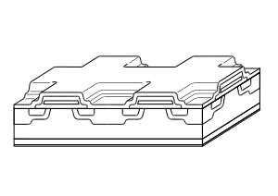
Cross section of a Power MOSFET, with square cells. A typical transistor is constituted of several thousand cells
Main article: Power MOSFET
Power MOSFETs have a different structure than the one presented above.^{[49]} As with most power devices, the structure is vertical and not planar. Using a vertical structure, it is possible for the transistor to sustain both high blocking voltage and high current. The voltage rating of the transistor is a function of the doping and thickness of the N-epitaxial layer (see cross section), while the current rating is a function of the channel width (the wider the channel, the higher the current). In a planar structure, the current and breakdown voltage ratings are both a function of the channel dimensions (respectively width and length of the channel), resulting in inefficient use of the "silicon estate". With the vertical structure, the component area is roughly proportional to the current it can sustain, and the component thickness (actually the N-epitaxial layer thickness) is proportional to the breakdown voltage.^{[50]}
Power MOSFETs with lateral structure are mainly used in high-end audio amplifiers and high-power PA systems. Their advantage is a better behaviour in the saturated region (corresponding to the linear region of a bipolar transistor) than the vertical MOSFETs. Vertical MOSFETs are designed for switching applications.^{[51]}

DMOS
DMOS stands for double-diffused metal–oxide–semiconductor. Most power MOSFETs are made using this technology.

RHBD MOSFETs
Semiconductor sub-micrometer and nanometer electronic circuits are the primary concern for operating within the normal tolerance in harsh radiation environments like outer space. One of the design approaches for making a radiation-hardened-by-design (RHBD) device is Enclosed-Layout-Transistor (ELT). Normally, the gate of the MOSFET surrounds the drain, which is placed in the center of the ELT. The source of the MOSFET surrounds the gate. Another RHBD MOSFET is called H-Gate. Both of these transistors have very low leakage current with respect to radiation. However, they are large in size and take more space on silicon than a standard MOSFET.
Newer technologies are emerging for smaller devices for cost saving, low power and increased operating speed. The standard MOSFET is also becoming extremely sensitive to radiation for the newer technologies. A lot more research works should be completed before space electronics can safely use RHBD MOSFET circuits of nanotechnology.
When radiation strikes near the silicon oxide region (STI) of the MOSFET, the channel inversion occurs at the corners of the standard MOSFET due to accumulation of radiation induced trapped charges. If the charges are large enough, the accumulated charges affect STI surface edges along the channel near the channel interface (gate) of the standard MOSFET. Thus the device channel inversion occurs along the channel edges and the device creates off-state leakage path, causing device to turn on. So the reliability of circuits degrades severely. The ELT offers many advantages. These advantages include improvement of reliability by reducing unwanted surface inversion at the gate edges that occurs in the standard MOSFET. Since the gate edges are enclosed in ELT, there is no gate oxide edge (STI at gate interface), and thus the transistor off-state leakage is reduced very much.
Low-power microelectronic circuits including computers, communication devices and monitoring systems in space shuttle and satellites are very different than what we use on earth. They are radiation (high-speed atomic particles like proton and neutron, solar flare magnetic energy dissipation in earth's space, energetic cosmic rays like X-ray, gamma ray etc.) tolerant circuits. These special electronics are designed by applying very different techniques using RHBD MOSFETs to ensure the safe space journey and also space-walk of astronauts.

MOSFET analog switch
MOSFET analog switches use the MOSFET channel as a low–on-resistance switch to pass analog signals when on, and as a high impedance when off. Signals flow in both directions across a MOSFET switch. In this application, the drain and source of a MOSFET exchange places depending on the relative voltages of the source/drain electrodes. The source is the more negative side for an N-MOS or the more positive side for a P-MOS. All of these switches are limited on what signals they can pass or stop by their gate–source, gate–drain and source–drain voltages; exceeding the voltage, current, or power limits will potentially damage the switch.

Single-type MOSFET switch
This analog switch uses a four-terminal simple MOSFET of either P or N type. In the case of an n-type switch, the body is connected to the most negative supply (usually GND) and the gate is used as the switch control. Whenever the gate voltage exceeds the source voltage by at least a threshold voltage, the MOSFET conducts. The higher the voltage, the more the MOSFET can conduct. An N-MOS switch passes all voltages less than V_{gate}–V_{tn}. When the switch is conducting, it typically operates in the linear (or ohmic) mode of operation, since the source and drain voltages will typically be nearly equal.
In the case of a P-MOS, the body is connected to the most positive voltage, and the gate is brought to a lower potential to turn the switch on. The P-MOS switch passes all voltages higher than V_{gate}–V_{tp} (threshold voltage V_{tp} is negative in the case of enhancement-mode P-MOS).
A P-MOS switch will have about three times the resistance of an N-MOS device of equal dimensions because electrons have about three times the mobility of holes in silicon.

Dual-type (CMOS) MOSFET switch
This "complementary" or CMOS type of switch uses one P-MOS and one N-MOS FET to counteract the limitations of the single-type switch. The FETs have their drains and sources connected in parallel, the body of the P-MOS is connected to the high potential (V_{DD}) and the body of the N-MOS is connected to the low potential (Gnd). To turn the switch on, the gate of the P-MOS is driven to the low potential and the gate of the N-MOS is driven to the high potential. For voltages between V_{DD}–V_{tn} and Gnd–V_{tp}, both FETs conduct the signal; for voltages less than Gnd–V_{tp}, the N-MOS conducts alone; and for voltages greater than V_{DD}–V_{tn}, the P-MOS conducts alone.
The voltage limits for this switch are the gate–source, gate–drain and source–drain voltage limits for both FETs. Also, the P-MOS is typically two to three times wider than the N-MOS, so the switch will be balanced for speed in the two directions.
Tri-state circuitry sometimes incorporates a CMOS MOSFET switch on its output to provide for a low-ohmic, full-range output when on, and a high-ohmic, mid-level signal when off.

See also
- BSIM
- High electron mobility transistor (HEMT)
- Polysilicon depletion effect
- Transistor model

References
  - Jump up ^ Yuhua Cheng, Chenming Hu (1999). "§2.1 MOSFET classification and operation". MOSFET modeling & BSIM3 user's guide. Springer. p. 13. ISBN 0-7923-8575-6.
  - Jump up ^ U.A.Bakshi, A.P.Godse (2007). "§8.2 The depletion mode MOSFET". Electronic Circuits. Technical Publications. pp. 8–2. ISBN 978-81-8431-284-3.
  - Jump up ^ "Intel 45nm Hi-k Silicon Technology".
  - Jump up ^ Electronic Circuit Symbols
  - Jump up ^ IEEE 315
  - Jump up ^ Microelectronic Circuit Design, Jaeger, Blalock - Figure 4.15 IEEE Standard MOS transistor circuit symbols.
  - Jump up ^ "Using a MOSFET as a Switch". 090507 brunningsoftware.co.uk
  - Jump up ^ This model was introduced by H Shichman and DA Hodges (1968). "Modeling and simulation of insulated-gate field-effect transistor switching circuits". IEEE Journal of Solid-state circuits SC–3: 285–289. doi:10.1109/JSSC.1968.1049902. and often is called the Shichman-Hodges model.
  - Jump up ^ For example, see Yuhua Cheng, Chenming Hu (1999). MOSFET modeling & BSIM3 user's guide. Springer. ISBN 0-7923-8575-6.. The most recent version of the BSIM model is described in Sriramkumar V., Navid Paydavosi,Darsen Lu, Chung-Hsun Lin,Mohan Dunga, Shijing Yao, Tanvir Morshed,Ali Niknejad, and Chenming Hu (2012). "BSIM-CMG 106.1.0beta Multi-Gate MOSFET Compact Model". Department of EE and CS, UC Berkeley. Retrieved 2012-04-01.
  - Jump up ^ P R Gray, P J Hurst, S H Lewis, and R G Meyer (2001). Analysis and Design of Analog Integrated Circuits (Fourth Edition ed.). New York: Wiley. pp. 66–67. ISBN 0-471-32168-0.
  - Jump up ^ P. R. van der Meer, A. van Staveren, A. H. M. van Roermund (2004). Low-Power Deep Sub-Micron CMOS Logic: Subthreshold Current Reduction. Dordrecht: Springer. p. 78. ISBN 1-4020-2848-2.
  - Jump up ^ Degnan, Brian. "Wikipedia fails subvt".
  - Jump up ^ Mead, Carver (1989). Analog VLSI and Neural Systems. Reading, MA: Addison-Wesley. p. 370. ISBN 9780201059922.
  - Jump up ^ Leslie S. Smith, Alister Hamilton (1998). Neuromorphic Systems: Engineering Silicon from Neurobiology. World Scientific. pp. 52–56. ISBN 981-02-3377-9.
  - Jump up ^ Satish Kumar (2004). Neural Networks: A Classroom Approach. Tata McGraw-Hill. p. 688. ISBN 0-07-048292-6.
  - Jump up ^ Manfred Glesner, Peter Zipf, Michel Renovell (2002). Field-programmable Logic and Applications: 12th International Conference. Dordrecht: Springer. p. 425. ISBN 3-540-44108-5.
  - Jump up ^ Eric A. Vittoz (1996). "The Fundamentals of Analog Micropower Design". In Chris Toumazou, Nicholas C. Battersby, and Sonia Porta. Circuits and systems tutorials. John Wiley and Sons. pp. 365–372. ISBN 978-0-7803-1170-1.
  - Jump up ^ Sandeep K. Shukla, R. Iris Bahar (2004). Nano, Quantum and Molecular Computing. Springer. p. 10 and Fig. 1.4, p. 11. ISBN 1-4020-8067-0.
  - Jump up ^ Ashish Srivastava, Dennis Sylvester, David Blaauw (2005). Statistical Analysis and Optimization For VLSI: Timing and Power. Springer. p. 135. ISBN 0-387-25738-1.
  - Jump up ^ C Galup-Montoro & Schneider MC (2007). MOSFET modeling for circuit analysis and design. London/Singapore: World Scientific. p. 83. ISBN 981-256-810-7.
  - Jump up ^ Norbert R Malik (1995). Electronic circuits: analysis, simulation, and design. Englewood Cliffs, NJ: Prentice Hall. pp. 315–316. ISBN 0-02-374910-5.
  - Jump up ^ PR Gray, PJ Hurst, SH Lewis & RG Meyer. §1.5.2 p. 45. ISBN 0-471-32168-0.
  - Jump up ^ A. S. Sedra and K.C. Smith (2004). Microelectronic circuits (Fifth Edition ed.). New York: Oxford. p. 552. ISBN 0-19-514251-9.
  - Jump up ^ A. S. Sedra and K.C. Smith. p. 250, Eq. 4.14. ISBN 0-19-514251-9.
  - Jump up ^ For a uniformly doped p-type substrate with bulk acceptor doping of N_{A} per unit volume,
with n_{i} the intrinsic mobile carrier density per unit volume in the bulk. See, for example, Narain Arora (2007). "Equation 5.12". Mosfet modeling for VLSI simulation: theory and practice. World Scientific. p. 173. ISBN 981-256-862-X.
  - Jump up ^ "Body effect". Equars.com. Retrieved 2012-06-02.
  - Jump up ^ "1960 – Metal Oxide Semiconductor (MOS) Transistor Demonstrated: John Atalla and Dawon Kahng fabricate working transistors and demonstrate the first successful MOS field-effect amplifier (U.S. Patent 3,102,230 filed in 1960, issued in 1963)".
  - Jump up ^ "The Silicon Engine | 1948 – Conception of the Junction Transistor". Computer History Museum. 2007.
  - Jump up ^ "Computer History Museum – The Silicon Engine | 1955 – Photolithography Techniques Are Used to Make Silicon Devices". Computerhistory.org. Retrieved 2012-06-02.
  - Jump up ^ Robert H. Cushman. "2-1/2-generation μP's-$10 parts that perform like low-end mini's". EDN September 20 1975.
  - Jump up ^ "Computer History Museum – The Silicon Engine | 1963 – Complementary MOS Circuit Configuration is Invented". Computerhistory.org. Retrieved 2012-06-02.
  - Jump up ^ "Computer History Museum – Exhibits – Microprocessors". Computerhistory.org. Retrieved 2012-06-02.
  - Jump up ^ "International Technology Roadmap for Semiconductors".
  - Jump up ^ "1965 – "Moore's Law" Predicts the Future of Integrated Circuits". Computer History Museum.
  - Jump up ^ Kaushik Roy, Kiat Seng Yeo (2004). Low Voltage, Low Power VLSI Subsystems. McGraw-Hill Professional. Fig. 2.1, p. 44. ISBN 0-07-143786-X.
  - Jump up ^ Kaushik Roy, Kiat Seng Yeo (2004). Low Voltage, Low Power VLSI Subsystems. McGraw-Hill Professional. Fig. 1.1, p. 4. ISBN 0-07-143786-X.
  - Jump up ^ Dragica Vasileska, Stephen Goodnick (2006). Computational Electronics. Morgan & Claypool. p. 103. ISBN 1-59829-056-8.
  - Jump up ^ "Frontier Semiconductor Paper" (PDF). Retrieved 2012-06-02.
  - Jump up ^ Wai-Kai Chen (2006). The VLSI Handbook. CRC Press. Fig. 2.28, p. 2–22. ISBN 0-8493-4199-X.
  - Jump up ^ A Comparison Of Spike, Flash, Sper and Laser Annealing For 45nm CMOS: http://www.mrs.org/s_mrs/sec_subscribe.asp?CID=2593&DID=109911&action=detail
  - Jump up ^ VLSI wiring capacitance. IBM Journal of Research and Development.
  - Jump up ^ D Soudris, P Pirsch, E Barke (Editors) (2000). Integrated Circuit Design: Power and Timing Modeling, Optimization, and Simulation (10th Int. Workshop). Springer. p. 38. ISBN 3-540-41068-6.
  - Jump up ^ Michael Orshansky, Sani Nassif, Duane Boning (2007). Design for Manufacturability And Statistical Design: A Constructive Approach. New York 309284: Springer.
  - Jump up ^ http://www.revera.com/VeraFlex/hkmg_approaches.htm
  - Jump up ^ Jean-Pierre Colinge, Cynthia A. Colinge (2002). Physics of Semiconductor Devices. Dordrecht: Springer. p. 233, Figure 7.46. ISBN 1-4020-7018-7.
  - Jump up ^ Eicke R. Weber, Jarek Dabrowski (Editors) (2004). Predictive Simulation of Semiconductor Processing: Status and Challenges. Dordrecht: Springer. p. 5, Figure 1.2. ISBN 3-540-20481-4.
  - Jump up ^ See, for example, PM Zeitzoff, JA Hutchby, HR Huff (2002). "Figure 12: Simplified cross section of FinFET double-gate MOSFET.". In Yoon-Soo Park, Michael Shur, William Tang, eds. Frontiers in electronics: future chips : proceedings of the 2002 Workshop on Frontiers in Electronics (WOFE-02), St Croix, Virgin Islands, USA, 6–11 January 2002. World Scientific. p. 82. ISBN 981-238-222-4. and J-H Lee, J-W Lee, H-A-R Jung and B-K Choi (2009). "Comparison of SOI FinFETs and bulk FinFETs: Figure 2". Silicon-on-Insulator Technology and Devices. The Electrochemical Society. p. 102. ISBN 1-56677-712-7.
  - Jump up ^ Techweb. Techweb (2010-01-29). Retrieved on 2010-11-27.
  - Jump up ^ Power Semiconductor Devices, B. Jayant Baliga, PWS publishing Company, Boston. ISBN 0-534-94098-6
  - Jump up ^ Power MOSFET Basics: Understanding MOSFET Characteristics Associated With The Figure of Merit. element14. Retrieved on 2010-11-27.
  - Jump up ^ Power MOSFET Basics: Understanding Gate Charge and Using It To Assess Switching Performance. element14. Retrieved on 2010-11-27.

External links
 | Wikimedia Commons has media related to MOS(FET).
- Understanding power MOSFET data sheet parameters - NXP PDF Application Note AN11158
- An introduction to depletion-mode MOSFETs
- Power MOSFETs
- Criteria for Successful Selection of IGBT and MOSFET Modules
- MOSFET Process Step by Step A Flash slide showing the fabricating process of a MOSFET in detail step
- MOSFET Calculator MOSFET Calculator
- Advanced MOSFET Issues Advanced MOSFET issues. ecee.colorado.edu. Retrieved on 2010-11-27.
- MOSFET applet Very nice applet that helps to understand MOSFET.
- Dr. Ulrich Nicolai, Dr. Tobias Reimann, Prof. Jürgen Petzoldt, Josef Lutz: Application Manual IGBT and MOSFET Power Modules, 1. Edition, ISLE Verlag, 1998, ISBN 3-932633-24-5 PDF-Version
- Wintrich, Arendt; Nicolai, Ulrich; Tursky, Werner; Reimann, Tobias (2011). [PDF-Version Application Manual 2011] (2nd ed.). Nuremberg: Semikron. ISBN 978-3-938843-66-6.
- MIT OpenCourseWare courses:
  - MIT Open Courseware 6.002 – Spring 2007 – Link to the intro electrical engineering course at MIT on circuits and electronics.
  - MIT Open Courseware 6.012 – Fall 2009 – Link to a more advanced class taught at MIT all about microelectronics and MOSFETs
- Georgia Tech BJT and FET Slides Slides from a Microelectronic Circuits class at Georgia Tech
- CircuitDesign: MOS Diffusion Parasitics Crude illustrations of MOS diffusion structure and sample circuit layouts to minimize their parasitics
- Course on Physics of Nanoscale Transistors
- Notes on Ballistic MOSFETs by Dr. Lundstrom – theory of ballistic MOSFETs.
- Veendrick, Harry J. M. (2008). Nanometer CMOS ICs, from Basics to ASICs. New York: Springer. p. 770. ISBN 978-1-4020-8332-7.
[hide]
- v
- t
- e
Electronic components
Semiconductor devices | - Avalanche diode  - Barretter  - Bipolar junction transistor (BJT)  - Darlington transistor  - DIAC  - Diode  - Field-effect transistor (FET)  - Insulated-gate bipolar transistor (IGBT)  - Integrated circuit (IC)  - JFET  - Light-emitting diode (LED)  - Memistor  - Memristor  - MOSFET  - Photodetector  - PIN diode  - Silicon-controlled rectifier (SCR)  - Thyristor  - Transistor  - TRIAC  - Unijunction transistor (UJT)  - Varicap  - Zener diode
Vacuum tubes | - Audion  - Beam tetrode  - Compactron  - Diode  - Fleming valve  - Heptode  - Hexode  - Nonode  - Nuvistor  - Octode  - Pentagrid  - Pentode  - Photomultiplier  - Selectron tube  - Tetrode  - Triode  - Williams tube
Vacuum tubes (RF) | - Backward wave oscillator (BWO)  - Cavity magnetron  - Crossed-field amplifier (CFA)  - Gyrotron  - Inductive output tube (IOT)  - Klystron  - Maser  - Phototube  - Traveling-wave tube (TWT)
Cathode ray tubes | - Beam deflection tube  - Charactron  - Iconoscope  - Magic eye tube  - Monoscope  - Storage tube  - Video camera tube
Gas-filled tubes | - Cold cathode  - Crossatron  - Dekatron  - Ignitron  - Krytron  - Mercury-arc valve  - Neon lamp  - Nixie tube  - Thyratron  - Trigatron  - Voltage-regulator tube
Adjustable | - Potentiometer  - Variable capacitor
Passive | - Connector  - Audio and video  - Electrical power  - RF  - Ferrite  - Fuse  - resettable  - Resistor  - Thermistor  - Transformer  - Varistor
Reactive | - Capacitor  - types  - Ceramic resonator  - Crystal oscillator  - Inductor

Categories:
- Transistor types

Navigation menu
- Create account
- Log in
- Article
- Talk
- Read
- Edit
- View history
Top of Form

Bottom of Form

- Main page
- Contents
- Featured content
- Current events
- Random article
- Donate to Wikipedia

Interaction
- Help
- About Wikipedia
- Community portal
- Recent changes
- Contact page

Toolbox

Print/export

Languages
- العربية
- বাংলা
- Български
- Català
- Česky
- Dansk
- Deutsch
- Eesti
- Español
- فارسی
- Français
- 한국어
- हिन्दी
- Hrvatski
- Bahasa Indonesia
- Italiano
- עברית
- Lietuvių
- Монгол
- Nederlands
- 日本語
- Norsk nynorsk
- Polski
- Português
- Русский
- Simple English
- Slovenčina
- Српски / srpski
- Suomi
- Svenska
- தமிழ்
- ไทย
- Türkçe
- Українська
- Tiếng Việt
- 中文
- Edit links
- This page was last modified on 30 October 2013 at 18:29.
- Text is available under the Creative Commons Attribution-ShareAlike License; additional terms may apply. By using this site, you agree to the Terms of Use and Privacy Policy.
Wikipedia® is a registered trademark of the Wikimedia Foundation, Inc., a non-profit organization.
- Privacy policy
- About Wikipedia
- Disclaimers
- Contact Wikipedia
- Developers
- Mobile view

